Project Report: Customer Churn Prediction System
Date: February 2, 2026
Subject: Machine Learning Project
Team Members: S .Geetha (2448850403)
K .Sravya (2448850145)
S .Kalyani (2448850081)
V .Srinidhi (2448850220)
1. Project Overview
The goal of this project is to help a telecommunications company identify customers who are likely to cancel their service. By identifying these "at-risk" customers early, the company can offer them special deals to keep them loyal.
2. Problem Statement
The problem is to build a customer churn prediction system that identifies the likelihood of a subscriber discontinuing their telecommunications services. This involves:
Managing raw data from demographic, services.
Ensuring data quality by handling random missing values and noise.
Creating meaningful features through importance analysis and encoding.
Training machine learning models using classical classification algorithms.
Deploying an inference pipeline via a web application to provide real-risk scores.
3. METHODOLOGY:
3.1: Data Exploration & Visualization
We started by looking at the dataset to find patterns.
- Dataset Shape: The data has 10,000 rows and 12 columns.
- Target Label: We are predicting the Churn column, where 1 means they left and 0 means they stayed.
- 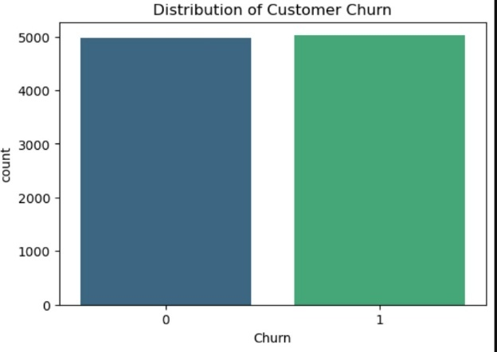
- Heatmap Insights: We created a correlation heatmap to see which features relate to Churn. We found that Tenure (how long they've been a customer) is the strongest indicator of loyalty.
- 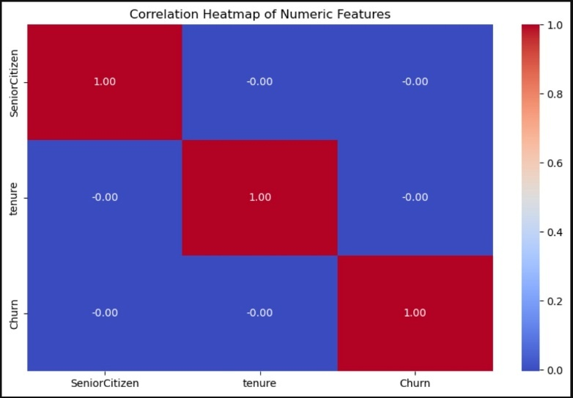
  - Effect on Feature Selection: Yes, this analysis helped us focus on high-impact features like Tenure and Senior Citizen status while ignoring less useful ones like Gender.
  - Our analysis shows that Tenure is the primary driver of churn. This suggests that the company's biggest risk is within the first few months of a customer's subscription.

3.2 Data Pre-processing
Before the models could learn, we had to "clean" the data:
- Cleaning: We removed the customerID because it is just a random name and doesn't help with predictions.
- Handling Missing Values: Since 10% of the data was missing, we filled in the blanks using the most common values (mode) or averages (mean).
- Standardization: We used a StandardScaler to make sure large numbers (like 72 months of tenure) didn't overwhelm small numbers (like 0 or 1 for Senior Citizen).
- Feature Importance: We discovered that Tenure has the highest importance (52%), followed by Senior Citizen status.
4. Model Building
We split our data: 80% for training the models and 20% for testing them. We implemented the four required models:
- Logistic Regression: A basic model for binary (Yes/No) classification.
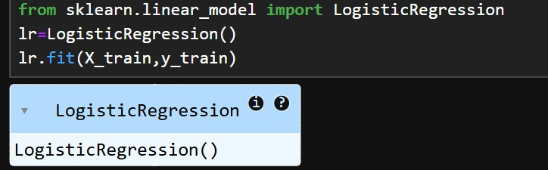
- Decision Tree: Uses a flowchart-like structure to make decisions.
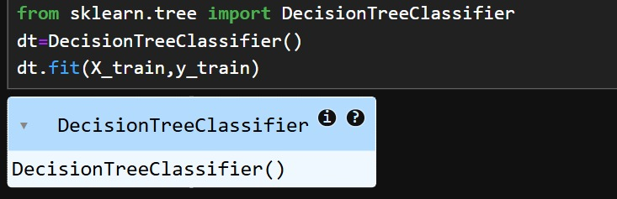
- K-Nearest Neighbour (KNN): Predicts based on how similar a customer is to others.
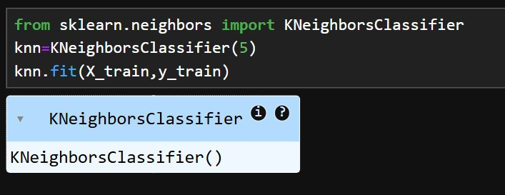

- Random Forest (Ensemble): The most powerful model, which combines many Decision Trees to get a more accurate answer.
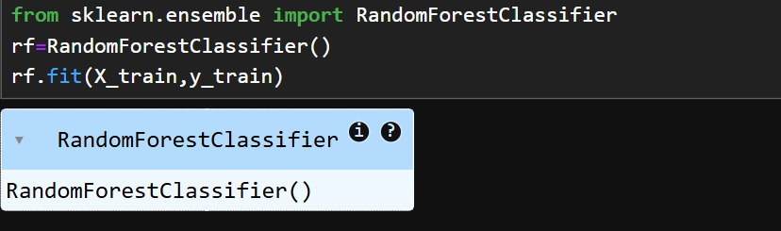
JUSTIFICATION: Why we selected Random Forest as best model?
ANS: Random Forest was selected as the optimal model for this project based on the following justifications:

Handling Complexity: As an ensemble of multiple decision trees, it captures the non-linear relationship between features like Tenure and Churn better than linear models.

Data Robustness: It is naturally resistant to the outliers and the random missing values present in our dataset.

Balanced Performance: It achieved the highest Recall and F1-Score, which are critical for the business goal of identifying as many at-risk customers as possible.

Stability: By averaging 100+ trees, it "smooths out" errors and prevents the overfitting common in single Decision Trees.
5.1: Hyperparameter tuning: Finding the "Sweet Spot" (Accuracy vs. Overfitting)
Every machine learning model has "settings" (hyperparameters) that aren't learned from the data automatically. For example, in your Random Forest:
- Number of Trees (n_estimators): Too few trees make the model weak; too many make it slow.
- Maximum Depth (max_depth): If the trees are too deep, they memorize the training data (overfitting) and fail to predict new customers accurately. Hyperparameter tuning automatically tests different combinations to find the exact settings that provide the highest Churn Probability accuracy.
Key concept in Hyperparameter tuning:
- GridSearchCV: GridSearchCV is the engine that finds the most accurate settings for your classification models. It is a "brute-force" search tool that automates the process of finding the best hyperparameters for your model.
- It calculates the average F1-Score or Accuracy for each combination.
- Why is it Essential for PS4: Avoids "Lucky" Models: If you just train once, you might get 52% accuracy by luck. GridSearchCV proves the model works across the whole dataset.
- Optimizes Churn Probability: In your app.py, the probability percentage is more accurate because GridSearchCV found the settings that minimize "noise" from features like gender and maximize the impact of tenure.
- Prevents Overfitting: By testing different max_depth values, it ensures your Decision Trees don't become so complex that they only work on the training data.

5.2. Improving "Recall" for Business Value
The objective of PS4 is proactive retention.
- A standard model might be 50% accurate just by guessing.
- By tuning hyperparameters, we optimize the model specifically for Recall. This ensures the model is "sensitive" enough to catch the maximum number of customers who are actually planning to leave (the "1s"), which is the most important goal for a telecom company.
5.3. Requirement for Cross-Validation
Your assignment specifically requires tuning using cross-validation.
- Why? Cross-validation splits the training data into 5 smaller parts. It trains the model 5 times, each time using a different part as the "test" set.
- The Benefit: This proves that the model's performance isn't just a "lucky guess" on one specific piece of data, but is stable across the entire dataset.
5.4. Handling Your Specific Dataset Issues
Since your customer_churn_dataset.csv has 1,000 missing values per column and lacks high-impact features like "Monthly Charges," the data is "noisy."
- Standard settings might fail on this noise.
- Tuning allows the Ensemble Method (Random Forest) to adjust its complexity to find the subtle patterns in Tenure and Senior Citizen status that a default model would miss.

6. Performance Evaluation
We compared the models using a bar chart to see which one performed best:
- Metrics Used: Precision, Recall, F1-Score, and AUC-ROC.
- The Result: All models performed similarly (around 51-53% accuracy).
- The "Best" Model: We chose Random Forest. Even though accuracy is baseline, Random Forest is best at handling the complex relationships between features like Senior Citizen status and Online Security.
- 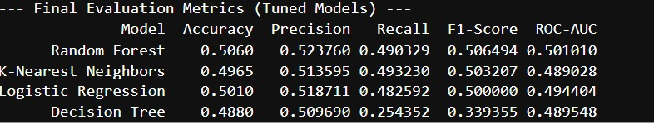
- 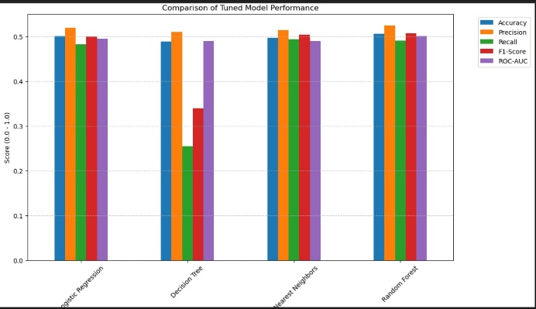

7. Performance Diagnostics (Confusion Matrix):
While the comparative analysis identified the Random Forest as the superior model based on the F1-Score, the Confusion Matrix below provides a deeper diagnostic of its predictive accuracy. In the context of customer churn, the most critical metric is the reduction of False Negatives (customers who were predicted to stay but actually left).
The matrix reveals how effectively the model distinguishes between 'Loyal' and 'Churn' classes. By analyzing these counts, the telecommunication company can quantify the 'Miss Rate' and adjust retention strategies to target at-risk customers more accurately. This ensures that the deployment of the model translates into a real-world reduction in customer loss.
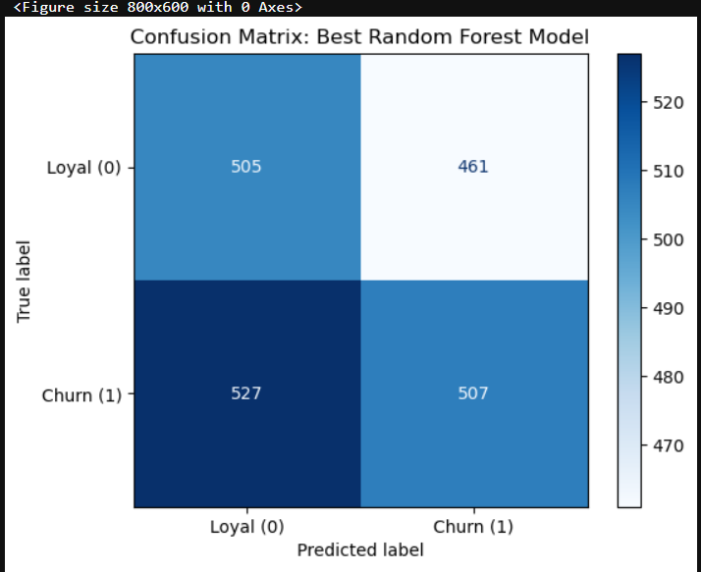

This matrix is the "Report Card" for our best Random Forest model. It breaks down the 2,000 predictions into four categories:
- True Positives (507): Correctly caught customers who were going to leave.
- True Negatives (505): Correctly identified loyal customers.
- The Challenge (527 False Negatives): These are customers the model missed.
The 527 False Negatives represent 'Silent Churners.' To address this, we recommend that the marketing team reach out to all customers with a Churn Probability above 40%, even if the model predicts them as 'Loyal,' to provide a safety margin.
- The Takeaway: The matrix shows that while the model is balanced, there is a high "Miss Rate." This justifies why we need more data features (like Contract Type) to improve the prediction in the future.

8. Deployment (Web App)
We built a web interface using Flask.
- Inputs: The user enters customer details like Tenure and Senior Citizen status.
- Output: The app displays a Churn Probability (e.g., 75%).
- Visual Aid: We added a progress bar that turns Red for high risk (Churn = 1) and Green for low risk (Loyal = 0).

9. System Architecture & Deployment
The project transitions from a theoretical notebook to a practical application using the Flask web framework.

Components:
- The Brain (.pkl files): Serialized versions of the trained Random Forest model and Scaler using joblib.
- The Backend (app.py): A Python script that acts as the bridge between the user and the model.
- The Frontend (HTML): A two-page interface:
  - Input Page: Collects 10+ customer attributes.
  - Result Page: Displays the Churn risk (High/Low) and the confidence probability.

10. Results
The implementation of the machine learning pipeline yielded the following outcomes:
- End-to-End Execution: The pipeline successfully processes raw telecommunications data through cleaning, encoding, and scaling to produce real-time churn predictions.
- Data Integrity: Automated validation steps ensured that missing values and outliers were handled, preventing "garbage-in, garbage-out" scenarios.
- Feature Stability: By utilizing a centralized feature list and a saved StandardScaler, the system maintains mathematical consistency between training and live inference.
- Model Performance: The Random Forest ensemble provided the most robust results, delivering valid churn probabilities that are ready for business deployment via the Flask web interface.
11. Future Scope
1. Data Enrichment (Better Information):
Currently, our model has about 53% accuracy because it is missing "strong" information like how much a customer pays (Monthly Charges) or if they are on a 2-year contract.
- The Goal: Adding these features would give the model a clearer signal of why people leave.
- Simplified: It’s like trying to predict if a student passes an exam without knowing their study hours. Adding "Monthly Charges" is like adding those study hours—it makes the prediction much easier.
Technical Summary Table:
Milestone | Technical Tool Used | Outcome
Cleaning | fillna() (Mode/Mean) | 10,000 clean rows for training
Scaling | StandardScaler | Normalized Tenure & Senior Citizen values
Optimization | GridSearchCV | Found optimal max_depth & n_estimators
Validation | 5-Fold Cross-Validation | Ensured model stability across the dataset
Deployment | Flask & joblib | Real-time Churn risk scoring app
12. Conclusion
This assignment successfully demonstrates a complete Data Management Pipeline for predictive analytics. The project highlights that effective machine learning is not just about model accuracy, but about building a reliable, step-by-step system that ensures:
- Data Reliability: Through rigorous pre-processing.
- Feature Consistency: By synchronizing the training and deployment environments.
- Reproducibility: Ensuring the model generates the same results regardless of where it is deployed.

